6.68: From Eq. (6.7), with 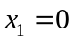,
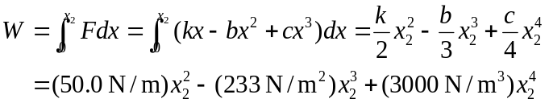

a) When 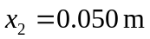, 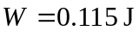, or 0.12 J to two figures. b) When 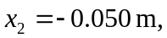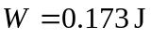, or 0.17 J to two figures. c) It’s easier to stretch the spring; the quadratic 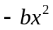 term is always in the -direction, and so the needed force, and hence the needed work, will be less when 

